Major TV networks stand with CNN, decline to replace its White House pool crew
 | Brian Stelter |  | Andrew Kirell
Updated Sep 21, 2026, 5:05 PM ET | PUBLISHED Sep 20, 2026, 11:11 PM ET
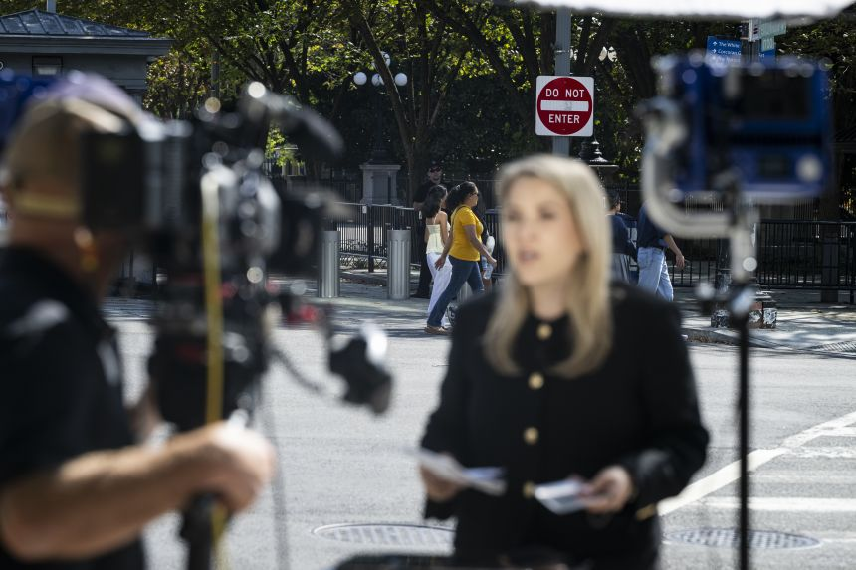
The White House grounds are seen behind CNN senior White House reporter Betsy Klein after the network was denied entry on September 19, 2026. Graeme Sloan/Getty Images
The major television networks are standing with CNN by declining to replace its White House pool crew after the Trump administration barred the network from fulfilling its assigned duties on Monday.
“The public has a vital interest in receiving accurate, independent information about its government. No administration should restrict a news organization because it objects to its reporting,” ABC, CBS, CNN, Fox News and NBC said in a rare joint statement.
The decision means the shared TV pool will not cover President Donald Trump’s events designated for pool coverage, according to an email Monday from Bryan Boughton, the Fox News Washington bureau chief who currently chairs the pool.
“This follows the White House’s position preventing CNN from fulfilling its assigned pool duties,” Boughton wrote to other pool subscribers. “There will be no replacement pool put in place.”
Under a longstanding arrangement, the five networks take turns filming the president and providing live footage to one another and the wider press corps. Local TV stations, newspaper websites and media outlets worldwide rely on that coverage.
Related article
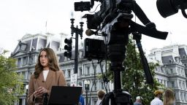
CNN, MS NOW and Politico sue Trump administration over White House access
CNN Correspondent Julia Benbrook prepares for a television report on a street corner outside the White House grounds after earlier being denied entry, on September 19, 2026 in Washington, DC. Reporters from MS NOW, CNN and Politico were barred from the White House a day after President Trump said he was banning the three outlets from the property. Graeme Sloan/Getty Images
“This is to advise that, effective today, the TV pool will not be covering events designated as pool coverage of the President,” Boughton wrote.
All other TV pool coverage “will continue as normal, including Congress, VIPs, and selected events in Washington and around the country,” he added.
CNN’s Kaitlan Collins explained Monday morning that the pool action means “that when the president does anything today, there will be no TV camera with the president that is broadcasting and sharing this footage” with the wider press corps and networks around the world.
Trump’s first live event on Monday with no TV press pool — a ribbon-cutting ceremony for his new helipad — was livestreamed to the White House website. However, Trump’s remarks were indiscernible throughout the video; the helicopter’s loud noise completely drowned out his voice.
Still photographers and their newsrooms are also showing solidarity with the banned outlets by withholding images of Trump’s appearances until the end of Monday.
Photographers from The New York Times, The Associated Press, Agence France-Presse, Reuters and Getty Images — all on Monday’s photo pool duty — are taking part in the action.
Although not every outlet is publicizing their participation, sources described the response to CNN as near-universal among photographers. The press corps photographed Trump’s departure aboard Marine One, but the images were not distributed on the wires.
The Times said it would not publish or distribute Monday’s pool images in support of the targeted newsrooms. The Washington Post, which is not on photo pool duty, said it would also withhold photographs of Trump’s appearances “until midnight Eastern time.”
The AP also confirmed its participation, saying: “No news organization — or person — should be retaliated against by the government over the words they use.”
The actions deepen the dispute that began Friday when the president said he was “banning” CNN, MS NOW and Politico from the White House.
Reporters for all three publications were turned away from the White House complex on Saturday morning. The outlets have filed a First Amendment lawsuit to challenge the restriction.
As part of the regular pool rotation, CNN was scheduled to act as the TV pool on Monday, and was assigned as the TV pool network that would accompany Trump to New York for the annual United Nations General Assembly this week.
But the White House’s Sunday night press schedule did not list any television network as the primary TV pool for Monday.
Hearst, which owns local TV stations across the country, was listed as the “secondary” TV crew in DC, and Real America’s Voice, a small pro-Trump network, was listed as the “secondary” crew for the New York trip.
The “secondary” TV crew typically attends pool events and can question the president, but does not perform the duties of the primary TV pool.
Related article
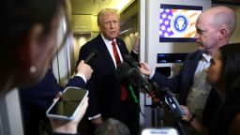
What is the White House press pool, and why is it now under threat?
President Donald Trump speaks to members of the press on October 19, 2025 aboard Air Force One. Alex Wong/Getty Images
Early Monday, Trump reiterated the ban in a Truth Social post, writing, “Trump bans CNN, MSNOW, and Politico from White House,” alongside a news article.
As part of pool coverage, each network takes a daily turn supplying a camera operator, an audio technician and a producer or reporter. While the technical crew records the president, the producer or reporter coordinates the live feed by phone, taking notes and asking questions.
That system, which has remained mostly unchanged for decades, lets a single TV crew provide coverage for many news organizations when space or access is limited, making CNN’s exclusion consequential beyond its own newsroom.
Presidential coverage is also costly, with multi-day trips costing tens of thousands of dollars for the news outlets involved.
CNN secured its place in the White House TV pool after suing the Reagan administration and ABC, CBS and NBC in 1981. The pool later expanded to include Fox News.
“CNN’s mission to report on the U.S. government will continue regardless of any attempts to restrict physical access to the White House and other government buildings, or any other attempts to impede our journalism,” the network said in a statement on Saturday.
“We have a right under the U.S. Constitution to do our reporting without hindrance or interference from the government and this ban is an illegal assault on this fundamental right,” the network added.
This story has been updated with additional information.
CNN’s Kevin Liptak and Andy Rose contributed to this report.

